Tut-5 (Solution)

A1. A Simple Graph is a graph in which each edge connects two different vertices and there is no more than one edge that connects any pair of vertices.

A2. 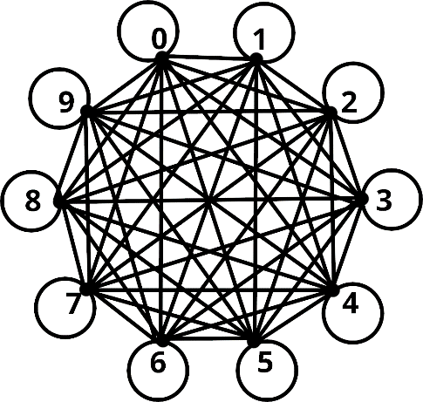

A3. Vertices – 8
Edges – 12
Degree of a – 3
Degree of b – 2
Degree of c – 4
Degree of d – 0
Degree of e – 6
Degree of g – 4
Degree of h – 2
Degree of i – 3
Isolated vertices: d
Pendant vertices: none

A4. Let us assume that a simple graph exists in which no two vertices have the same degree. Since this is a simple graph, the degree of any one vertex can not be more than (n-1) if there are n vertices. Therefore since no two vertices have the same degree we can say an arbitrary vertex v₀ has a degree 0, v₁ has a degree 1, … v_{n-1} has a degree n-1.
However, if any one vertex has a degree of n-1 (where n > 2) then that means it is connected to every other vertex in the simple graph which means it is not possible to have a vertex of degree 0. This contradicts our assumption and thus we can say that at least 2 vertices of a simple graph with 2 or more vertices will have the same degree.
A5.
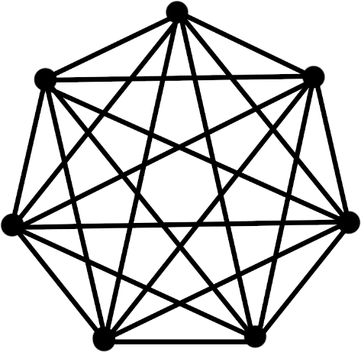
K₇
K_{1,8}


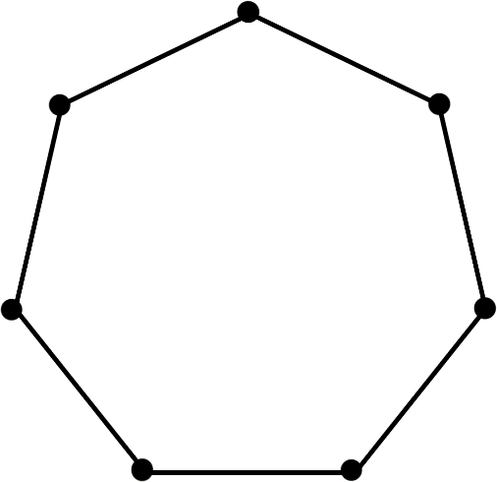
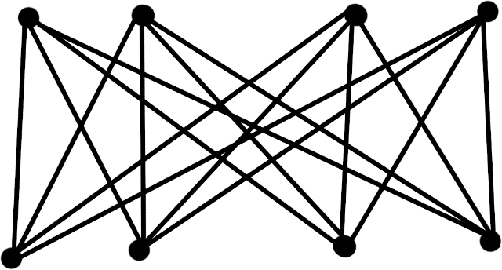
C₇
K_{4,4}

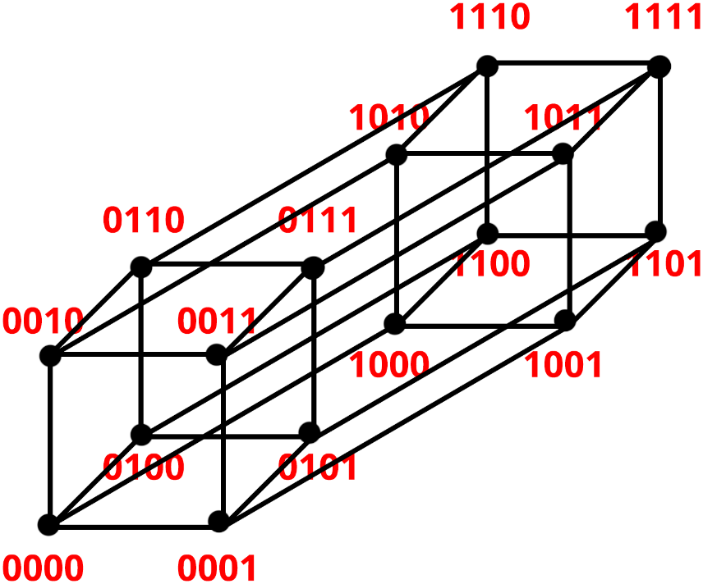
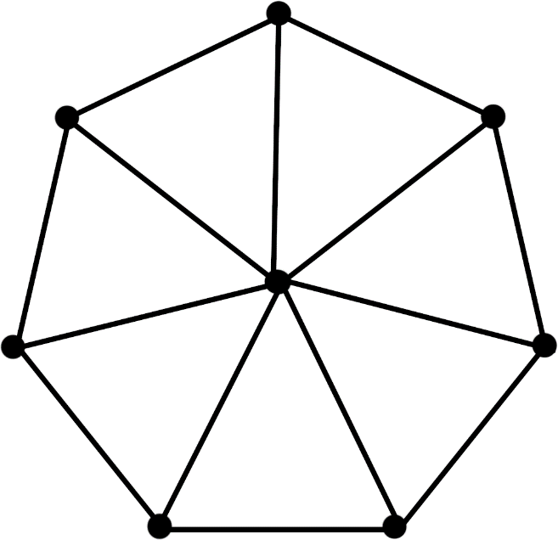
Q₄
W₇

A6. a) Yes
b) No

A9.
- K_{n} has n vertices and ^{n}C₂ edges
- C_{n} has n vertices and n edges
- W_{n} has (n+1) vertices and 2n edges
- K_{m, n} has (m+n) vertices and (m*n) edges
- Q_{n} has 2^{n} vertices and n*2^{n-1} edges

A10. There are 17 subgraphs of K₃ with at least 1 vertex.
- 3 with exactly 1 vertex
- 6 with exactly 2 vertices
- 8 with exactly 3 vertices
A13.
- K_{n} is regular for all values of n
C_{n} is regular for all values of n
W_{n} is regular for n = 3
Q_{n} is regular for all values of n
- For all m=n K_{m, n} is regular
- It has 5 vertices (K₅)

